ICSE CLASS 10TH SEMESTER 2 Maths EXAM 2022
SECTION-A
Question 1:
(i) The Probability of getting a number divisible by 3 in throwing a dice is:
(a) 1/6
(b) 1/3
(c) 1/2
(d) 2/3

(ii) The volume of a conical tent is 462 m³ and the area of the base is 154 m². The height of the cone is:
(a) 15m
(b) 12m
(c) 9m
(d) 24

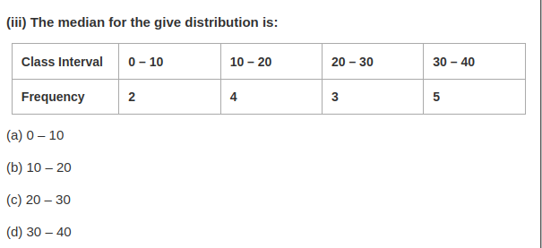

(iv) If two lines are perpendicular to one another then the relation between their slopes m1 and m2 is:
(a) m1 = m2
(b) m1 = 1/m2
(c) m1 = -m2
(d) m1× m2 = -1

(v) A lighthouse is 80m height. The angle of elevation of its top from a point 80m away from its foot along the same horizontal line is:
(a) 60°
(b) 45°
(c) 30°
(d) 90°
(vi) The modal class of a given distribution always corresponds to the:
(a) Interval with highest frequency
(b) Interval with lowest frequency
(c) The first interval
(d) The last interval
(vii) The coordinates of the point (-3, 5) on reflecting on the x axis are:
(a) (3, 5)
(b) (-3, -5)
(c) (3, -5
(d) (-3, 5)

(viii) ABCD is a cyclic quadrilateral. If ∠BAD = (2x + 5)° and ∠BCD = (x + 10)° then x is equal to:
(a) 65°
(b) 45°
(c) 55°
(d) 5°

(ix) A (1, 4), B (4, 1) and C (x, 4) are the vertices of ∆ABC. If the centroid of the triangle is G (4, 3) then x is equal to:
(a) 2
(b) 1
(c) 7
(d) 4

(x) The radius of a roller 100 cm long is 14 cm. The curved surface area of the roller is:
(Take π = 22/7)
(a) 13200 cm2
(b) 15400 cm2
(c) 4400 cm2
(d) 8800 cm2

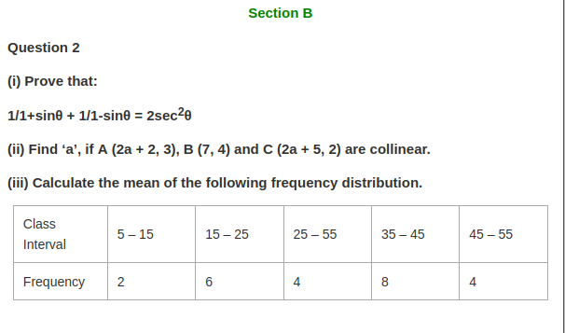
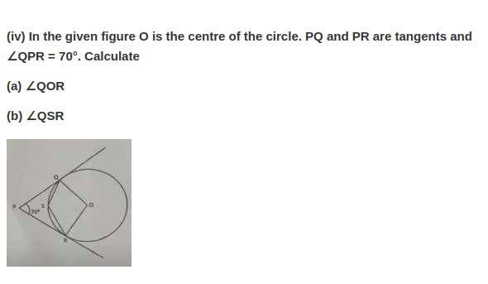

Question 3
(i) The bag contains 5 white, 2 red and 3 black balls. A ball is drawn at random. What is the probability that the ball drawn is a red ball?
(ii) A solid cone of radius 5 cm and height 9 cm is melted and made into small cylinders of radius of 0.5 cm and height 1.5 cm. find the number of cylinders so formed.
(iii) Two lamp posts AB and CD each of height 100 m are on either side of the road. P is a point on the road between the two lamp posts. The angle of elevation of the top of the lamp posts from the point P are 60 and 40. Find the distance PB and PD.
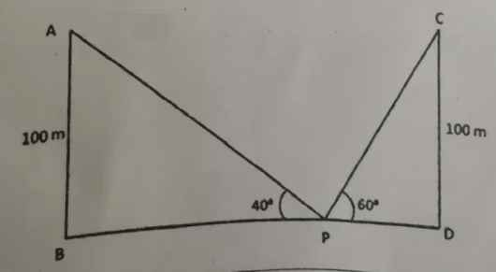

iv) Marks obtain by 100 students in an examination are given below.
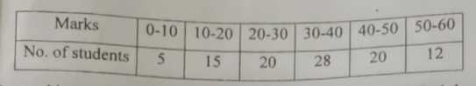
Draw a histogram for the given data using graph paper and find the mode. Take 2 cm = 10 mark along one axis and 2 cm = 10 students along the other axis.
Question 4:
(i) Find a point P which divides internally the line segment joining the points A (-3, 9) and B (1, -3) in the ratio 1:3.
(ii) A letter of the word ‘SECONDARY’ is selected at random. What is the probability that the letter selected is not a vowel?
(iii) Use a graph paper for this question. Take 2cm = 1 unit along both axes.
(a) Plot the points A (0, 4), B (2, 2), C(5, 2) and D (4, 0), E (0, 0) is the axes.

(b) Reflect B, C, D on the y-axis and name them as B’, C’ and D’ respectively.
(c) Join the points ABCDD’C’B’ and A in order and give a geometrical name to the closed figure.
(iv) A solid wooden cylinder is of radius 6cm and height 16cm. Two cones each of radius 2cm and height 6cm are drilled out of the cylinder. Find the volume of the remaining solid.
Take π = 22/7
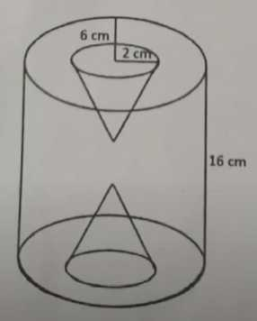
Question 5:
(i) Two chords AB and CD of a circle intersect externally at E. If EC = 2 cm, EA = 3cm and AB = 5 cm, Find the length of CD.
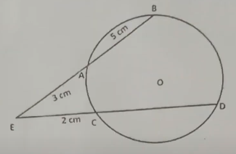
(ii) Line AB is perpendicular to CD. Coordinates of B, C and D are respectively (4 0), (0, -1 and (4, 3).
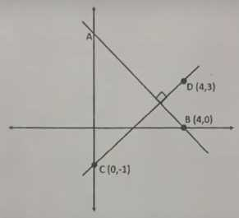
Find:
(a) Slope of CD
(b) Equation of AB

(iii) Prove that:
(1+sinθ)2 + (1-sinθ)2/2cos2θ = sec2θ + tan2θ
(iv) The mean of the following distribution is 50. Find the unknown frequency.

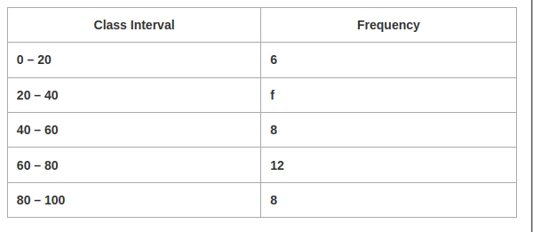

Question 6:
(i) Prove that:
1 + tan2θ/1+secθ = secθ
(ii) In the given figure A, B, C and D are points on the circle with centre O. Given ∠ABC = 62°
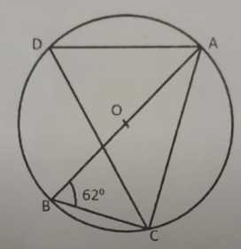
Find:
(a) ∠ADC
(b) ∠CAB
(iii) Find the equation a line parallel to the line 2x + y – 7 = 0 and passing through the intersection of the lines x + y – 4 = 0 and 2x – y = 8.
(iv) Marks obtained by 4 students in an examination are given below.
